**Logging using SLF4J**

**Exercise 1: Logging Error Messages and Warning Levels**

**Task:**

Write a Java application that demonstrates logging error messages and warning levelsusing SLF4J.

**Step-by-Step Solution:**

1. Add SLF4J and Logback dependencies to your `pom.xml` file:

<dependency>

<groupId>org.slf4j</groupId>

<artifactId>slf4j-api</artifactId>

<version>1.7.30</version>

</dependency>

<dependency>

<groupId>ch.qos.logback</groupId>

<artifactId>logback-classic</artifactId>

<version>1.2.3</version>

</dependency>

1. Create a Java class that uses SLF4J for logging:

import org.slf4j.Logger;

import org.slf4j.LoggerFactory;

public class LoggingExample {

private static final Logger logger = LoggerFactory.getLogger(

LoggingExample.class

);

public static void main(String[] args) {

logger.error("This is an error message");

logger.warn("This is a warning message");

}

}

**SOLUTION CHECKLIST**

1. Dependencies Added to **pom.xml**
2. Maven project refreshed and dependencies downloaded successfully
3. **Java** class **LogginExample** created under **src/main/java/com/cognizant**
4. **SLF4J Logger Initialized:**

private static final Logger logger = LoggerFactory.getLogger(

LoggingExample.class

);

1. Logging statements added inside **main** method:

logger.error("This is an error message");

logger.warn("This is a warning message");

1. Required imports added:

import org.slf4j.Logger;

import org.slf4j.LoggerFactory;

1. Application compiled using:

mvn compile

1. Log messages successfully printed in the console with appropriate **ERROR** and **WARN** levels

**OUTPUT**

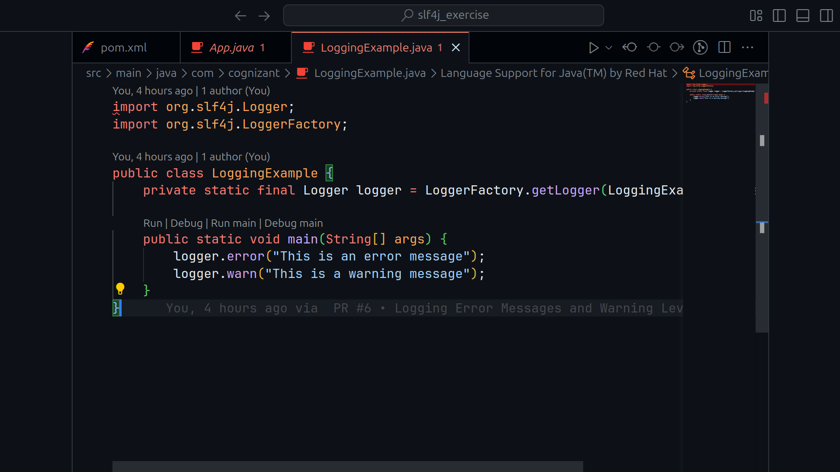

**RUNNING OUTPUT**

